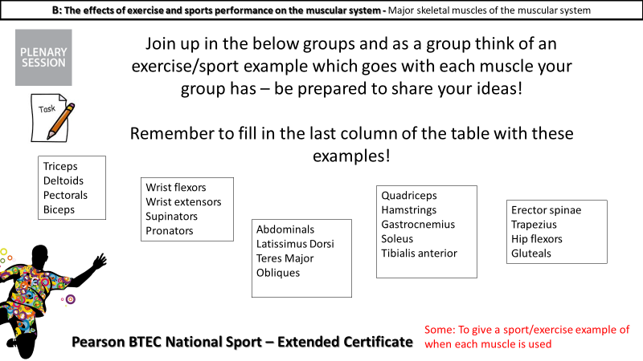

Using the grouped muscles think a sporting movement when all of these muscles are used to produce the action.

Can you label the heart correctly