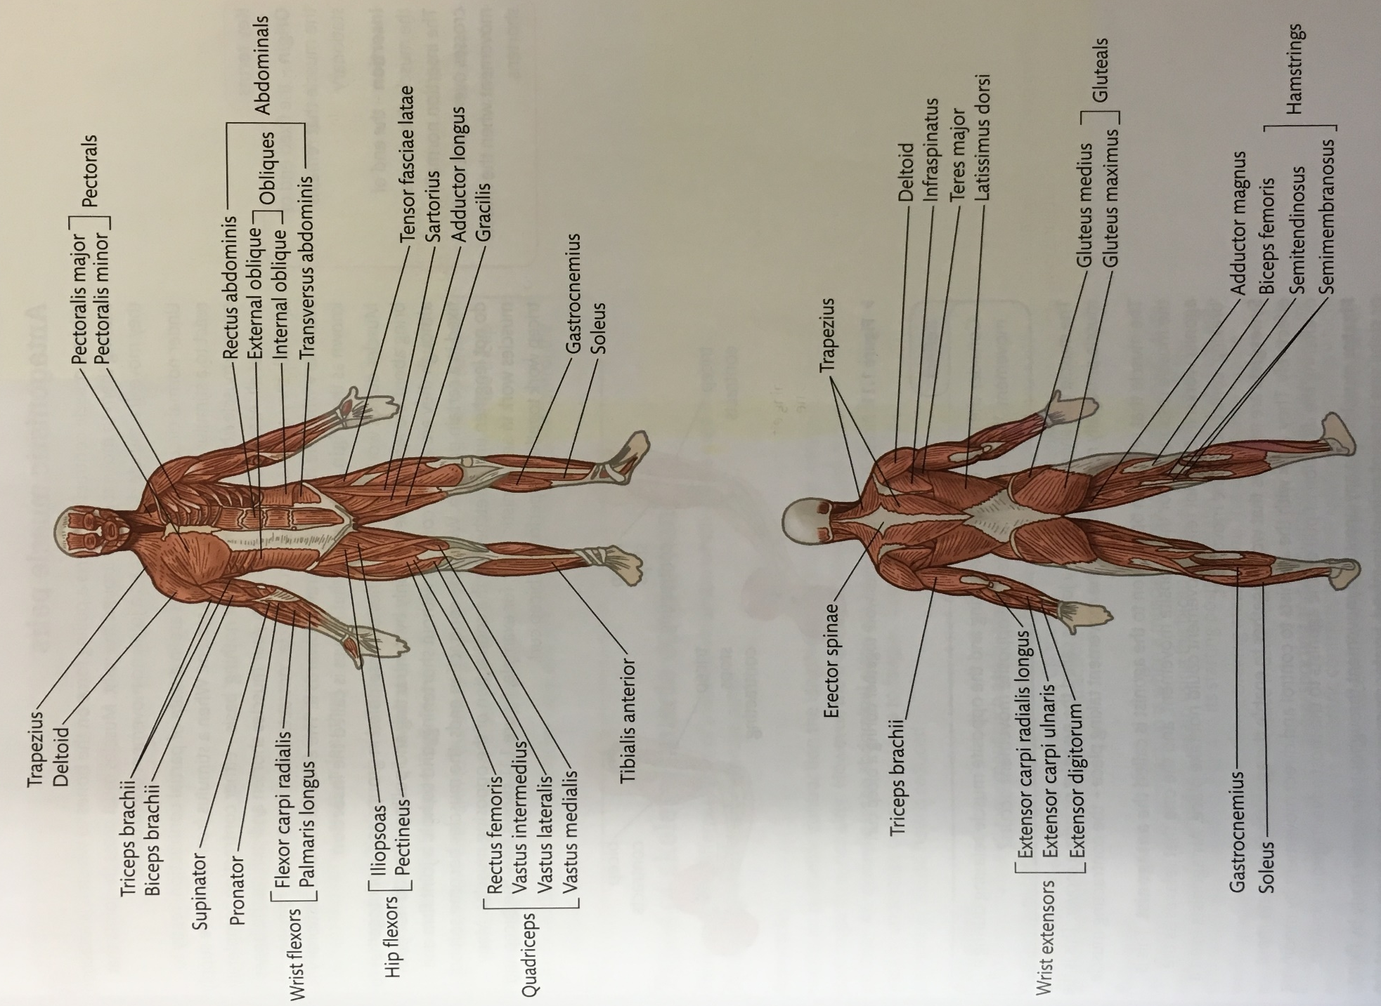
Major Skeletal Muscles of the Muscular System

