Blessed Hugh Faringdon Catholic School

Level 3 Applied Science
Subsidiary Diploma

Transition pack

Books for this course
https://www.amazon.co.uk/s?k=btec+applied
+science+level+3&i=stripbooks&crid=SJFTS QULQVLZ&sprefix=BTEC+Applied+scienc e+%2Cstripbooks%2C145&ref=nb_sb_ss_i_
1_21
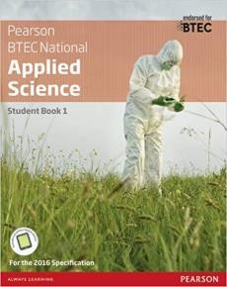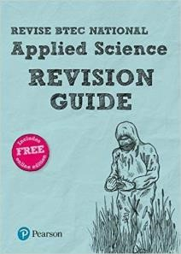
RECOMMENDED READING:
Below is a link to the specification for the BTEC level 3 Applied Science course: https://qualifications.pearson.com/en/qualifications/btec-nationals/applied-science-2016.html
Make sure you are on the correct tab: Extended certificate ( A-level equivalent),
- Pearson BTEC Level 3 National Extended Certificate in Applied Science 360 GLH (455 TQT)
- Equivalent in size to one A Level. 4 units of which 3 are mandatory and 2 are external. Mandatory content (83%). External assessment (58%).
- Designed for learners who are interested in learning about the sector alongside other fields of study, with a view to progressing to a wide range of higher education courses, not necessarily in applied science. To be taken as part of a programme of study that includes other appropriate BTEC Nationals or A Levels.
Recommended reasing
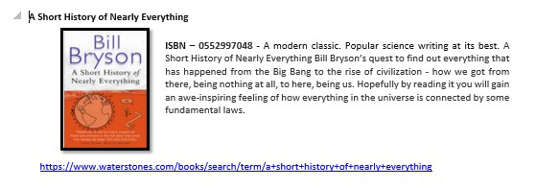

GETTING ORGANISED

You will find the following items essential for the BTEC course:

1. A lever arch file 2. A pack of subject dividers
- A notebook or lined paper to take notes from lessons.
- Plastic wallets 5. A copy of the textbook
6. A revision guide.

Pens, pencils, highlighters, ruler, rubber, calculator 8. A memory stick or external hard drive

As a student following a BTEC Extended Certificate course you will need to have the confidence to independently research scientific information and present your findings.

You will need to be able to follow detailed success criteria and produce clearly presented assignments which show that you have considered and included the required elements for success.
How the work should be presented:
You should produce a written report which is long enough to address the success criteria. You should focus on the requirements and avoid including any irrelevant (albeit interesting) information.
How the work will be assessed:
The work will be assessed by your teacher, on how well you have followed the success criteria and the level of detail you include in the assessment.

Task 1 Biology - DNA and the Genetic Code
In living organism’s nucleic acids (DNA and RNA have important roles and functions related to their properties. The sequence of bases in the DNA molecule determines the structure of proteins, including enzymes.
The double helix and its four bases store the information that is passed from generation to generation. The sequence of the base pair’s adenine, thymine, cytosine and guanine tell ribosomes in the cytoplasm how to construct amino acids into polypeptides and produce every characteristic we see. DNA can mutate leading to diseases including cancer, and sometimes anomalies in the genetic code are passed from parents to babies in disease such as cystic fibrosis or can be developed in unborn foetuses such as Down’s Syndrome.

Read the information on these websites:
http://www.bbc.co.uk/education/guides/z36mmp3/revision http://www.s-cool.co.uk/a-level/biology/dna-and-genetic-code And take a look at these videos:
http://ed.ted.com/lessons/the-twisting-tale-of-dna-judith-hauck http://ed.ted.com/lessons/where-do-genes-come-from-carl-zimmer

Produce a wall display to put up in your classroom in September. You might make a poster or do this using PowerPoint or similar. Your display should use images, keywords and simple explanations to:
- Define gene, chromosome, DNA and base pair
- Describe the structure and function of DNA and RNA
- Explain how DNA is copied in the body
- Outline some of the problems that occur with DNA replication and what the consequences of this might be.

Task 2 Chemistry – The Periodic table

Part A –
- Define the following terms: Atom, ion, compound, mixture, molecule, molecular mass, atomic mass
- Describe ionic bonding, covalent bonding and metallic bonding.
- Explain how the periodic table is arranged completing the following table to aid your explanation

Element | Symbol | Mass number | Atomic number | Number of electrons | Number of protons | Number  of  neutrons | Diagram
Lithium |  |  |  |  |  |  | 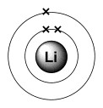
Sodium
Oxygen
Chlorine
Carbon
Hydrogen

Part B Groups 1 and 7

Outline the key features of the periodic table
- What patterns of reactivity are seen in group 1?
- What patterns of reactivity are seen in group 7?
- What are the key features of the group 1 elements?
- What are the key features of group 7 elements?
- What are the key features of the transition metals?

Part C Acids and Alkalis
Create a presentation or poster of the pH scale. Describe the properties of acids and alkalis, including and give an example of a substance for every number in the pH scale from 1 to 14. Include ideas about reactions with indicator substances such as litmus and U.I.

Task 3 – Physics – Waves and the EM spectrum Part A - Label parts a-f on the diagram below.
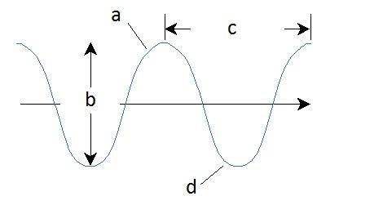

e

f

Research how electromagnetic waves are used in industries and by organisations such as the NHS.
Write a report include the following
- Describe how scientists and technicians in the communication industry, apply their knowledge of the electromagnetic spectrum when designing mobile phone and satellite communication. PASS
- Explain how fibre optics are used to transmit telephone and television signals.
- Outline how fibre optics are also used in diagnostic tools in medicine. Merit
- Suggest how the use of EM waves may be developed in future medical and communication applications DISTINCTION

Increasing your level of interest in Science
Science on social media
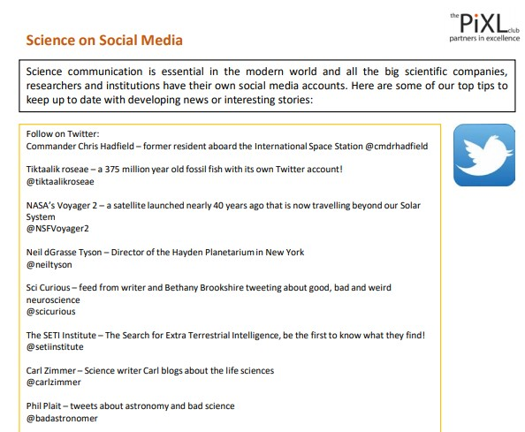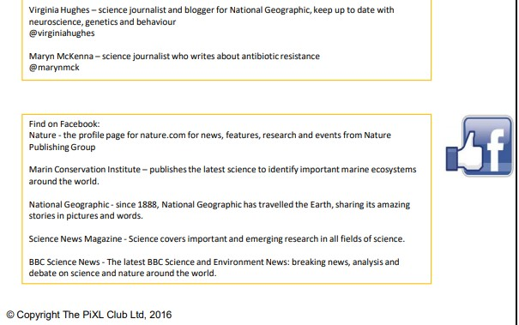

Unit 1 is an externally examined element of the BTEC Extended Certificate course.
Below are some examples of the type of questions that will be on your exam paper. Complete these practice questions.

Biology questions:

- State the maximum magnification that can be achieved by a light microscope and a transmission electron microscope.
Select your answers from the list below.
10x 40x 100x 400x 1500x 25 000x 50 000x 500 000x
light microscope ................................... x
transmission electron microscope ................................... x
[Total 2 marks]

- Describe what is meant by the term resolution.
..................................................................................................................................
..................................................................................................................................
..................................................................................................................................
.................................................................................................................................. [Total 2 marks]

- The figure below is an electron micrograph of xylem tissue in the stem of a plant.
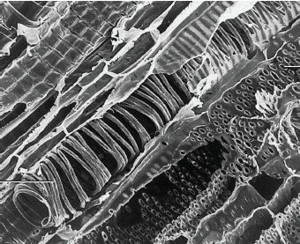

spiral band
pit

  - State one function of xylem tissue.
......................................................................................................................... .........................................................................................................................
[1] [Total 6 marks]
- (i) Explain what is meant by the term tissue.
.........................................................................................................................
.........................................................................................................................
.........................................................................................................................
.........................................................................................................................
[2]
(ii) Name one type of epithelial tissue found in the lungs.
.........................................................................................................................
.........................................................................................................................
[1] [Total 3 marks]
- Explain why the lungs can be considered to be an organ.
..................................................................................................................................
..................................................................................................................................
..................................................................................................................................
..................................................................................................................................
[Total 2 marks]

- In the lungs, goblet cells secrete mucus. The mucus is then moved by cilia. Name one cellular structure from the list below that is associated with each of the following functions. You must select a structure once only.
mitochondria ribosome Golgi vesicle centriole nucleus cytoskeleton
  - release of energy .......................................................................................
  - movement of cilia .......................................................................................
  - secrete mucus ............................................................................................
[Total 3 marks]
- (i) The figure below represents a transverse section of an artery and a vein.
Draw a line to show the relative position of the endothelium of the vein.
endothelium
artery vein
[1]
(ii) State two other ways in which the wall of an artery is different from the wall of a vein.
- ......................................................................................................................
.........................................................................................................................
- ......................................................................................................................
.........................................................................................................................
[2]
[Total 3 marks]

Chemistry questions:
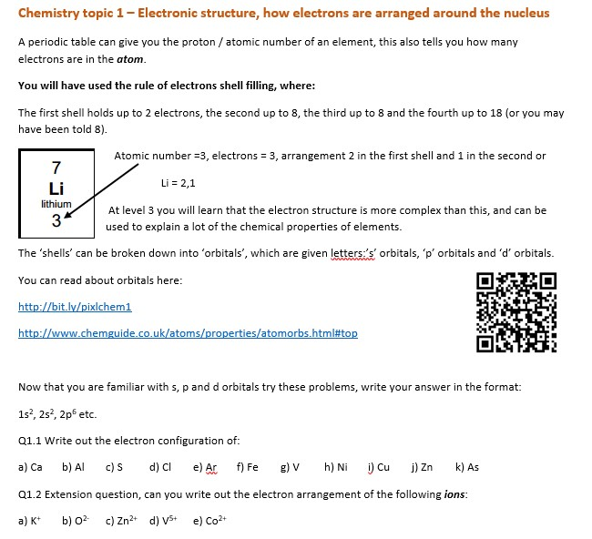
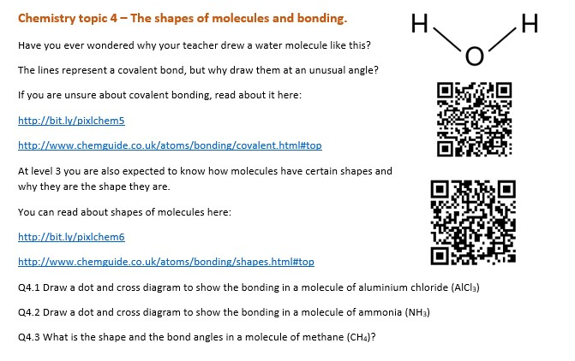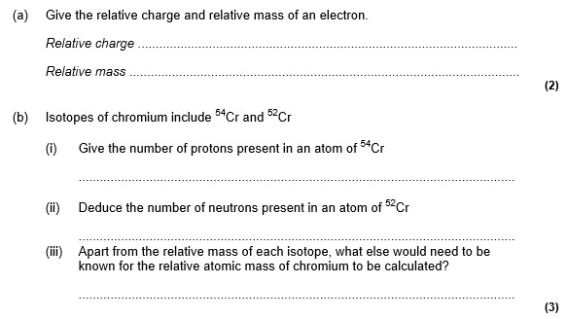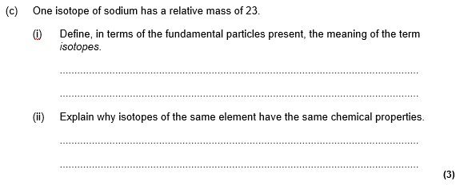

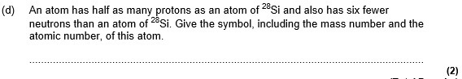

Physics questions:

