Y11 Sociology

Transition Project

Welcome to A-level Sociology!

You have chosen a subject that will ‘keep you on your toes’ and make you think in ways you couldn’t imagine. You will certainly have a very different outlook on society by the end of your course.

Please complete the activities in this booklet in readiness to begin your studies. This will show us your commitment and may be used alongside your GCSE grades and behaviour as entry criteria – sixth form study is hard work and there are no short cuts. Commitment to your studies is essential. Good Luck!

Overview of the course

This is a two-year course which ends with three two-hour papers each carrying an equal weighting towards your final A-level grade (A*-E). Topics we will cover will include:

Year 12 Year 13
Theories of Sociology Crime and Deviance
Methods of Sociology Beliefs in Society
Families & Households Methods of Sociology
Education Theories of Sociology

Look at the specification for more detail about these topics. You can find this at: https://filestore.aqa.org.uk/resources/sociology/specifications/AQA-7191-7192-SP-2015.PDF

You will be expected to know and understand (AO1) the information about the topics, to be able to apply (AO2) that knowledge and understanding and to be able to analyse and evaluate (AO3) that knowledge and understanding.

QUALIFICATION | A-level Sociology
Teacher Name(s) | Teacher of Sociology: Miss Giles  Subject Leader for Social Sciences: Ms McCarthy
Contact email(s) | e.giles@hughfaringdon.org  m.mccarthy@hughfaringdon.org
Exam board and link | AQA www.aqa.org.uk
Specification details | 7192
Recommended online learning | https://revisesociology.com/  https://www.senecalearning.com/  https://www.tutor2u.net/sociology  https://www.aqa.org.uk/subjects/sociology/as-and-a-level/sociology-7191-7192  https://thesociologyguy.com/a-level-sociology/  https://www.youtube.com/channel/UC6VpoZj33Df_rNb8KymCczw  https://napierpress.com/
Textbooks that are used | 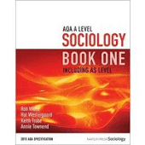  Year 12 textbook  by Rob Webb  published by Napier Press  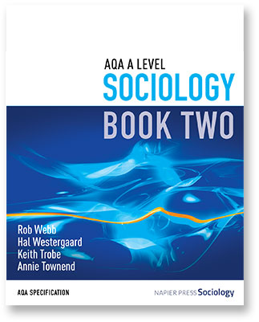  Year 13 textbook  by Rob Webb  published by Napier Press
Task 1: What’s involved in A Level Sociology?

Read the specification carefully (link on page 2) and make a note below of the sections there are to each topic:

Education……………………………………………………………………………………..………………………………………
………………………………………………………………………………………………………………………………………………
……………………………………………………………………………………………………………………………………………….
Theory and Methods (Year 1)………………………………………………………..………………………………………
………………………………………………………………………………………………………………………………………………
……………………………………………………………………………………………………………………………………………….
Families and Households………………………………………………………………..………………………………………
………………………………………………………………………………………………………………………………………………
……………………………………………………………………………………………………………………………………………….
Beliefs in Society…………………..………………………………………………………..………………………………………
………………………………………………………………………………………………………………………………………………
……………………………………………………………………………………………………………………………………………….
Crime and Deviance ……………………………………………………………………..………………………………………
………………………………………………………………………………………………………………………………………………
……………………………………………………………………………………………………………………………………………….
Theory and Methods (Year 2)………………………………………………………..………………………………………
………………………………………………………………………………………………………………………………………………
……………………………………………………………………………………………………………………………………………….
What do you think ‘Methods in Context’ means?
………………………………………………………..……………………………………………………………………………………..
………………………………………………………………………………………………………………………………………………
……………………………………………………………………………………………………………………………………………….
Task 2: What is Sociology?

Sociology is the study of society and of people and their behaviour. Sociology is evidence-based; not just about opinions but backed up by research carried out by sociologists. Sociologists argue that much of human behaviour is learned, and not instinctive. Much of this learning occurs in our early years and has a huge influence on our behaviour and development.

Watch the following clip and jot down 5 things that tell you what Sociology is:

https://www.youtube.com/watch?v=YnCJU6PaCio

- …………………………………………..……………………………………………………………………………………..

………………………………………………………………………………………………………………………………….

- …………………………………………..……………………………………………………………………………………..

………………………………………………………………………………………………………………………………….

- …………………………………………..……………………………………………………………………………………..

………………………………………………………………………………………………………………………………….

- …………………………………………..……………………………………………………………………………………..

………………………………………………………………………………………………………………………………….

- …………………………………………..……………………………………………………………………………………..

………………………………………………………………………………………………………………………………….

Task 3: Sociological perspectives

Sociologists generally argue that society is based on agreement (value consensus) or disagreement and conflict. The key consensus theory is functionalism and the key conflict theory is Marxism. You will come across many different perspectives in your A Level but this task will provide you with an introduction to 4 of the main perspectives.

Please complete the tasks on the following 4 pages on the following perspectives:
- Functionalism
- Feminism
- Marxism
- Postmodernism

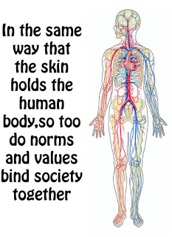
Functional functionalists

- Research Functionalism and produce a mind map in the space below, outlining the approach and the ‘Organic Analogy’.

- List at least 3 key functionalists below and briefly outline some of their arguments (e.g. Durkheim and his views on the structure of society).

………………………………………………………………………………………………………………………………………………

………………………………………………………………………………………………………………………………………………

………………………………………………………………………………………………………………………………………………

………………………………………………………………………………………………………………………………………………

………………………………………………………………………………………………………………………………………………

………………………………………………………………………………………………………………………………………………

- Watch the following You Tube clip of The Adjustment Bureau Trailer and link it to functionalism: www.youtube.com/watch?v=wZJ0TP4nTaE

………………………………………………………………………………………………………………………………………………

………………………………………………………………………………………………………………………………………………

………………………………………………………………………………………………………………………………………………
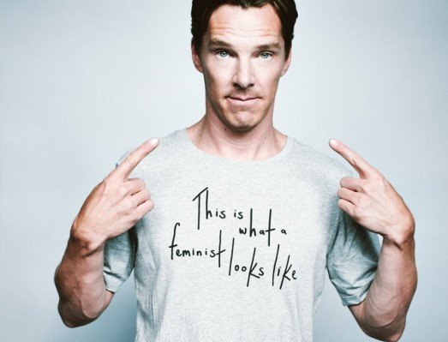
Fiery feminists

- Watch the following clip and summarise what it tells you about feminism in the space below. https://www.youtube.com/watch?v=CVB7BWHaUT4 (TEDx Covent Garden Women talk, What’s Feminist About Equality? Finn Mackay)

- List at least 3 key feminists below and briefly outline some of their arguments.

………………………………………………………………………………………………………………………………………………

………………………………………………………………………………………………………………………………………………

………………………………………………………………………………………………………………………………………………

………………………………………………………………………………………………………………………………………………

………………………………………………………………………………………………………………………………………………

………………………………………………………………………………………………………………………………………………

- Research @EverydaySexism (remember this is a public form and some content may not be appropriate and the school can take no responsibility over the content)

………………………………………………………………………………………………………………………………………………

………………………………………………………………………………………………………………………………………………

………………………………………………………………………………………………………………………………………………
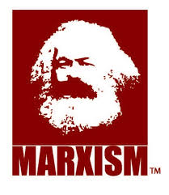
Magnificent Marxists

- Watch this YouTube clip www.youtube.com/watch?v=Vz3eOb6Yl1s and do some additional research on Marxism. Create a list of key terms and definitions below (e.g. Bourgeoisie, Proletariat).

- List at least 3 key Marxists below and briefly outline some of their arguments.

………………………………………………………………………………………………………………………………………………

………………………………………………………………………………………………………………………………………………

………………………………………………………………………………………………………………………………………………

………………………………………………………………………………………………………………………………………………

………………………………………………………………………………………………………………………………………………

………………………………………………………………………………………………………………………………………………

- Research examples of class inequality in within the UK contemporary society.

………………………………………………………………………………………………………………………………………………

………………………………………………………………………………………………………………………………………………

………………………………………………………………………………………………………………………………………………
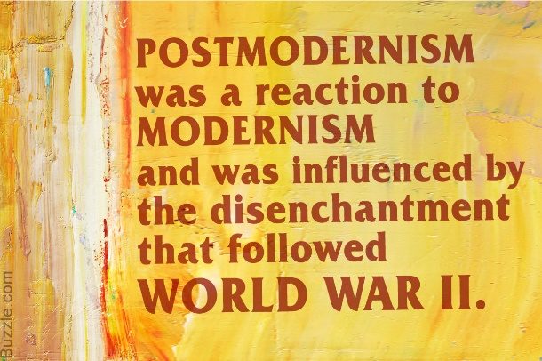
Passionate Postmodernists

- Do some research and fill in the table outlining the differences between modern and postmodern society.
Modernism | Postmodernism

- List at least 3 key postmodernists below and briefly outline some of their arguments.

………………………………………………………………………………………………………………………………………………

………………………………………………………………………………………………………………………………………………

………………………………………………………………………………………………………………………………………………

………………………………………………………………………………………………………………………………………………

………………………………………………………………………………………………………………………………………………

………………………………………………………………………………………………………………………………………………

- Find examples of post-modern changes in society e.g. consumer culture, same-sex marriage.

………………………………………………………………………………………………………………………………………………

………………………………………………………………………………………………………………………………………………

………………………………………………………………………………………………………………………………………………
Task 4: Reading and watching list
Choose something from the Reading and Watching List below that you can discuss with others in your first Sociology lesson.
Reading List
- Brave New World – Aldous Huxley
- Animal Farm – George Orwell
- 1984 – George Orwell
- Chavs: The Demonisation of the Working Class – Owen Jones
- The Establishment and How They Get Away With It – Owen Jones
- The Handmaid’s Tale – Margaret Atwood (also a series)
- Vox – Christina Dalcher
- The God Delusion – Richard Dawkins
- Outsiders: Studies in Sociology of Deviance – Howard S Becker
- Folk Devils and Moral Panics – Stanley Cohen
- A Glasgow Gang Observed – Patrick James
- Gang Leader For A Day – Sudhir Venkatesh
- Haralambos
- A wide range of newspapers including The Guardian and Independent
Watching List
- Any documentaries, including Panorama, Louis Theroux, Stacey Dooley, Mind of a Murderer etc
- Black Mirror series (Netflix)
- Years and Years (BBC i-player)
- Goodfellas
- The Godfather
- Legend
- My Scientology Movie
- The ‘Up’ series (eg. 56 Up, 63 Up) on Netflix or Youtube
- The Secret Life of 5 year olds
- McMafia (previously BBC i-player)
- Freedom Writer’s Diary
- Dangerous Minds
- Chernobyl (drama)
- When They See Us (Netflix)
- The Society (Netflix)
- Blood Diamond
- A Bug’s Life or Antz (for Marxism)
- Ted Talks/Sociology

Task 5: Essentials list

The following resources form part of the essential kit for A level. Please make sure you are ready for your first sociology lesson!
You will need to purchase the year one textbook on page 3 of this booklet (link below) once you are confirmed on the course after receiving your GCSE results. If you are eligible for Pupil Premium, then your textbook will be provided by the school. Any student can also apply for the 16-19 Bursary to help with study costs.
https://www.amazon.co.uk/AQA-Level-Sociology-Book-Including/dp/0954007913
We may have some second hand or discounted copies you can purchase from us in September.
You will also need the following stationery items. These items are all available in 6th form study for free from Mr Eassom in B11, or you may wish to purchase your own.
- A folder to fit A4 notes in (you may need additional ones throughout the course)
- Index dividers to organise your work by subsections matched to the specification
- A4 pad where you can remove notes / assessments to file or pass to your teachers
- Pens, Ruler, Calculator, Highlighter
- You may wish to purchase index cards for making revision flashcards

See you in September!

