Y11 Psychology

Transition Project

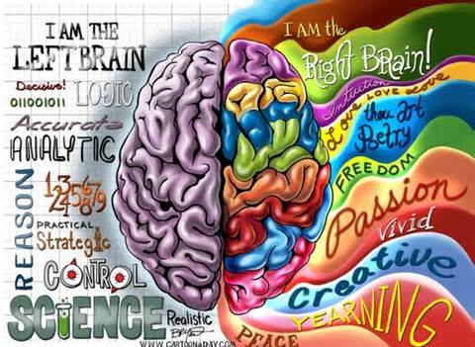

Welcome to A-level Psychology!

The A Level in Psychology is a fun, embracing yet challenging qualification. It will develop your thinking skills and vastly expand your knowledge of human behaviour.
Please complete the activities in this booklet in readiness to begin your studies. This will show us your commitment and may be used alongside your GCSE grades and behaviour as entry criteria – sixth form study is hard work and there are no short cuts. Commitment to your studies is essential. Good Luck!

Overview of the course

This is a two-year course which ends with three two-hour papers each carrying an equal weighting towards your final A-level grade (A*-E). Topics we will cover will include:

Year 12 Year 13
Approaches Biopsychology
Social influence Aggression
Memory Schizophrenia
Attachment Gender
Psychopathology Issues and debates
Research methods More research methods!

Look at the specification for more detail about these topics. You can find this at: https://filestore.aqa.org.uk/resources/psychology/specifications/AQA-7181-7182-SP-2015.PDF

You will be expected to know and understand (AO1) the information about the topics, to be able to apply (AO2) that knowledge and understanding and to be able to analyse and evaluate (AO3) that knowledge and understanding.
QUALIFICATION | A-level Psychology
Teacher Name(s) | Teacher of Psychology: Miss Giles  Subject Leader for Social Sciences: Ms McCarthy
Contact email(s) | e.giles@hughfaringdon.org  m.mccarthy@hughfaringdon.org
Exam board and link | AQA www.aqa.org.uk
Specification details | 7182
Recommended online learning | https://www.simplypsychology.org/a-level-psychology.html https://www.senecalearning.com/  https://www.tutor2u.net/psychology  https://www.aqa.org.uk/subjects/psychology/as-and-a-level/psychology-7181-7182  https://psychologylockdown.wordpress.com/  https://www.youtube.com/channel/UCEA_qlpBQW9WzzjYUQ5-iIg  https://www.youtube.com/channel/UCqqIPOTshm8EM8CCWkCy9Pg
Textbooks that are used | 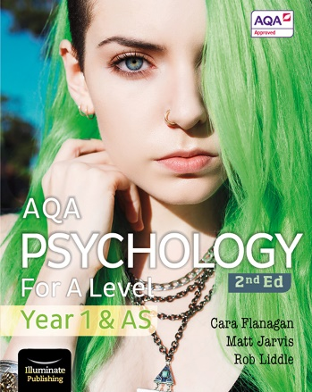  Year 12 textbook (2nd Ed)  by Cara Flanagan, Matt Jarvis, Rob Liddle  published by Illuminate Publishing  Out early May 2020  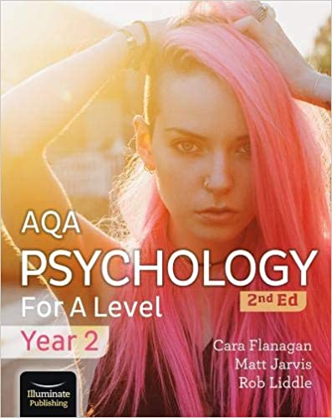  Year 13 textbook (2nd Ed)  by Cara Flanagan, Matt Jarvis, Rob Liddle  published by Illuminate Publishing  Out September 2020
Task 1: What’s involved in A Level Psychology?

Read the specification carefully (link on page 2) and make a note below of the sections there are to each topic:

Social influence…………………………………………………………………………..………………………………………
………………………………………………………………………………………………………………………………………………
……………………………………………………………………………………………………………………………………………….
Memory……………………………..………………………………………………………..………………………………………
………………………………………………………………………………………………………………………………………………
……………………………………………………………………………………………………………………………………………….
Attachment…………………………………………………………………………………..………………………………………
………………………………………………………………………………………………………………………………………………
……………………………………………………………………………………………………………………………………………….
Psychopathology…………………..………………………………………………………..………………………………………
………………………………………………………………………………………………………………………………………………
……………………………………………………………………………………………………………………………………………….
Approaches…………… ……………………………………………………………………..………………………………………
………………………………………………………………………………………………………………………………………………
……………………………………………………………………………………………………………………………………………….
Biopsychology………………………………………………………………………………..………………………………………
………………………………………………………………………………………………………………………………………………
……………………………………………………………………………………………………………………………………………….
Issues and debates..……………..………………………………………………………..………………………………………
………………………………………………………………………………………………………………………………………………
……………………………………………………………………………………………………………………………………………….
Gender……..…………………………………………………………………………………..………………………………………
………………………………………………………………………………………………………………………………………………
……………………………………………………………………………………………………………………………………………….
Schizophrenia……………………..………………………………………………………..………………………………………
………………………………………………………………………………………………………………………………………………
……………………………………………………………………………………………………………………………………………….
Aggression…………… ……………………………………………………………………..………………………………………
………………………………………………………………………………………………………………………………………………
……………………………………………………………………………………………………………………………………………….
Research methods..……………………………………………………………………..………………………………………
………………………………………………………………………………………………………………………………………………
……………………………………………………………………………………………………………………………………………….
………………………………………………………………………………………………………………………………………………
……………………………………………………………………………………………………………………………………………….
………………………………………………………………………………………………………………………………………………
……………………………………………………………………………………………………………………………………………….

Task 2: What is Psychology?

Psychology is the scientific study of the mind and behaviour, according to the American Psychological Association. Psychology is a multifaceted discipline and includes many sub-fields of study such areas as human development, sports, health, clinical, social behavior and cognitive processes. Psychology is really a very new science, with most advances happening over the past 150 years or so. However, its origins can be traced back to ancient Greece, 400 – 500 years BC.

Watch the following clip and jot down 5 things that tell you what Psychology is:

https://www.youtube.com/watch?v=vo4pMVb0R6M

- …………………………………………..……………………………………………………………………………………..

………………………………………………………………………………………………………………………………….

- …………………………………………..……………………………………………………………………………………..

………………………………………………………………………………………………………………………………….

- …………………………………………..……………………………………………………………………………………..

………………………………………………………………………………………………………………………………….

- …………………………………………..……………………………………………………………………………………..

………………………………………………………………………………………………………………………………….

- …………………………………………..……………………………………………………………………………………..

………………………………………………………………………………………………………………………………….

Task 3: Psychological approaches

There are some core approaches to Psychology that you need to know for your A level – they are different ways of explaining human behaviour. This task will provide you with an introduction to the main approaches.
Research them and explain the key terms, assumptions and psychologists that fit into each one. You will also need to briefly outline a study/experiment that supports its ideas. The following site will help you: http://www.simplypsychology.org/perspective.html

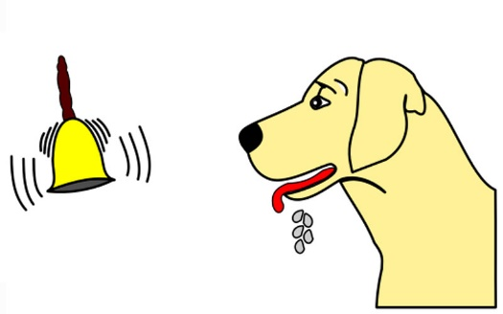
Behaviourist approach
Key terms, assumptions, psychologists: ……………………………………………………………………………………………………………………………………………

……………………………………………………………………………………………………………………………………………

……………………………………………………………………………………………………………………………………………

……………………………………………………………………………………………………………………………………………

……………………………………………………………………………………………………………………………………………

……………………………………………………………………………………………………………………………………………

……………………………………………………………………………………………………………………………………………

……………………………………………………………………………………………………………………………………………

A supporting study for this approach:

……………………………………………………………………………………………………………………………………………

……………………………………………………………………………………………………………………………………………

……………………………………………………………………………………………………………………………………………

……………………………………………………………………………………………………………………………………………

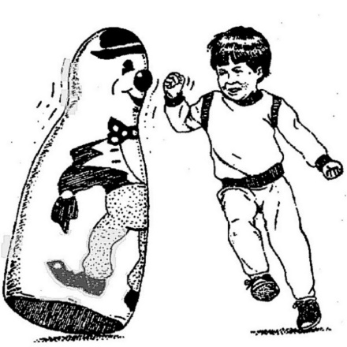
Social learning theory
Key terms, assumptions, psychologists:

……………………………………………………………………………………………………………………………………………

……………………………………………………………………………………………………………………………………………

……………………………………………………………………………………………………………………………………………

……………………………………………………………………………………………………………………………………………

……………………………………………………………………………………………………………………………………………

……………………………………………………………………………………………………………………………………………

……………………………………………………………………………………………………………………………………………

……………………………………………………………………………………………………………………………………………

A supporting study for this approach:

……………………………………………………………………………………………………………………………………………

……………………………………………………………………………………………………………………………………………

……………………………………………………………………………………………………………………………………………

……………………………………………………………………………………………………………………………………………

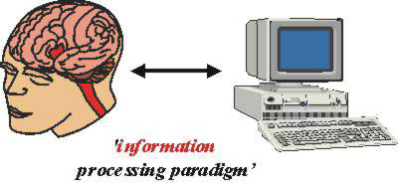
Cognitive approach
Key terms, assumptions, psychologists:

……………………………………………………………………………………………………………………………………………

……………………………………………………………………………………………………………………………………………

……………………………………………………………………………………………………………………………………………

……………………………………………………………………………………………………………………………………………

……………………………………………………………………………………………………………………………………………

……………………………………………………………………………………………………………………………………………

……………………………………………………………………………………………………………………………………………

……………………………………………………………………………………………………………………………………………

A supporting study for this approach:

……………………………………………………………………………………………………………………………………………

……………………………………………………………………………………………………………………………………………

……………………………………………………………………………………………………………………………………………

……………………………………………………………………………………………………………………………………………

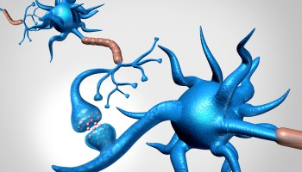
Biological approach
Key terms, assumptions, psychologists:

……………………………………………………………………………………………………………………………………………

……………………………………………………………………………………………………………………………………………

……………………………………………………………………………………………………………………………………………

……………………………………………………………………………………………………………………………………………

……………………………………………………………………………………………………………………………………………

……………………………………………………………………………………………………………………………………………

……………………………………………………………………………………………………………………………………………

……………………………………………………………………………………………………………………………………………

A supporting study for this approach:

……………………………………………………………………………………………………………………………………………

……………………………………………………………………………………………………………………………………………

……………………………………………………………………………………………………………………………………………

……………………………………………………………………………………………………………………………………………

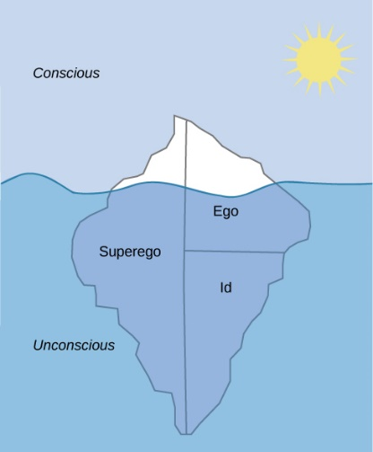
Psychodynamic approach
Key terms, assumptions, psychologists:

……………………………………………………………………………………………………………………………………………

……………………………………………………………………………………………………………………………………………

……………………………………………………………………………………………………………………………………………

……………………………………………………………………………………………………………………………………………

……………………………………………………………………………………………………………………………………………

……………………………………………………………………………………………………………………………………………

……………………………………………………………………………………………………………………………………………

……………………………………………………………………………………………………………………………………………

A supporting study for this approach:

……………………………………………………………………………………………………………………………………………

……………………………………………………………………………………………………………………………………………

……………………………………………………………………………………………………………………………………………

……………………………………………………………………………………………………………………………………………

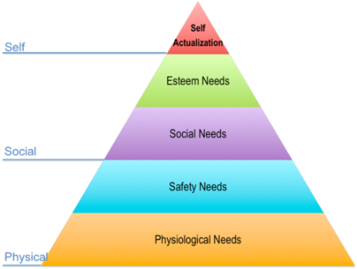
Humanistic approach
Key terms, assumptions, psychologists:

……………………………………………………………………………………………………………………………………………

……………………………………………………………………………………………………………………………………………

……………………………………………………………………………………………………………………………………………

……………………………………………………………………………………………………………………………………………

……………………………………………………………………………………………………………………………………………

……………………………………………………………………………………………………………………………………………

……………………………………………………………………………………………………………………………………………

……………………………………………………………………………………………………………………………………………

A supporting study for this approach:

……………………………………………………………………………………………………………………………………………

……………………………………………………………………………………………………………………………………………

……………………………………………………………………………………………………………………………………………

……………………………………………………………………………………………………………………………………………

Task 4: Reading and watching list
Choose something from the Reading and Watching List below that you can discuss with others in your first Psychology lesson.
Reading List
- The Psychology review subscription www.hoddereducation.co.uk
- Social Psychology for Dummies by Daniel Richardson
- Child Psychology and Development for Dummies by Laura
- The Lucifer Effect: How good people turn evil by Phillip Zimbardo
- One flew over the Cuckoo’s Nest by Chuck Palahniuk
- We need to talk about Kevin by Lionel Shriver
- Thinking Fast and Slow, by Daniel Kahneman, 2011
- The Social Animal Eleventh Edition by Elliot Aronson
- A secure base: clinical applications of attachment
- Thinking, Fast and Slow: Daniel Kahneman
- The man who mistook his wife for a hat: Oliver Sacks
- Mark Haddon The Curious Incident off the dog in the night time
- Harper Lee To kill a mockingbird
- The Psychopath: James Blair
- The Selfish Gene: Richard Dawkins
- Obedience to Authority Stanley Milgram
- Psychology in Football: Mark Nesti
- Clockwork Orange Anthony Burgess
- It’s Not Me, It’s You: Jon Richardson
- The Jigsaw Man: Paul Britton
- The case of Mary Bell: Gitta Sereny
- In Cold Blood: Truman Capote
- Gone Girl: Gillian Flynn
- Shutter Island: Dennis Lehane
Watching List
Attachment:
- Blackfish
- Good Will Hunting
- Mockingbird Don’t Sing
- The Troubled Child
- About Time
Biopsychology:
- Shutter Island
- Concussion
- Faces in the Crowd
Memory:
- 12 Angry Men
- 50 First Dates
- Memento
- The Notebook
- The Man with the 7 Second Memory
- Inside Out
Psychopathology:
- A Dangerous Method
- Girl, Interrupted
- As Good As It Gets
- Awakenings
- It’s Kind of a Funny Story
- Little Miss Sunshine
- Rain Man
- Side Effects
- Shutter Island
- The Men Who Stare At Goats
- A Beautiful Mind
Social influence:
- The Experimenter
- The Wave (Die Welle)
- 12 Angry Men
- Compliance
- Lord of the Flies
- Malcolm X
- The Stanford Prison Experiment
Or any of these:
- Channel 4: Three Identical Strangers
- Netflix: 100 Humans, The Creative Brain, Babies, The mind – explained
- Any documentaries, including Panorama, Louis Theroux, Stacey Dooley, Mind of a Murderer etc
- Derren Brown
- Ted Talks/Psychology

Task 5: Essentials list

The following resources form part of the essential kit for A level. Please make sure you are ready for your first psychology lesson!
You will need to purchase the year one textbook on page 3 of this booklet (link below) once you are confirmed on the course after receiving your GCSE results. If you are eligible for Pupil Premium, then your textbook will be provided by the school. Any student can also apply for the 16-19 Bursary to help with study costs.
https://www.amazon.co.uk/Psychology-Level-Year-Student-Book/dp/1912820420/ref=pd_lpo_14_t_2/260-3409868-9604340?_encoding=UTF8&pd_rd_i=1912820420&pd_rd_r=94fd7f69-d8d8-4590-bbf1-6593f58b7975&pd_rd_w=f9kNA&pd_rd_wg=8hKZQ&pf_rd_p=7b8e3b03-1439-4489-abd4-4a138cf4eca6&pf_rd_r=7RYQNJXQ3XN1MT16D9TA&psc=1&refRID=7RYQNJXQ3XN1MT16D9TA
We may have some second hand or discounted copies you can purchase from us in September.
You will also need the following stationery items. These items are all available in 6th form study for free from Mr Eassom in B11, or you may wish to purchase your own.
- A folder to fit A4 notes in (you may need additional ones throughout the course)
- Index dividers to organise your work by subsections matched to the specification
- A4 pad where you can remove notes / assessments to file or pass to your teachers
- Pens, Ruler, Calculator, Highlighter
- You may wish to purchase index cards for making revision flashcards

See you in September!

