NAME:________________________________

- This booklet is designed to expand your critical listening skills in preparation for the A level Music written paper.
- You may also be asked to form and communicate opinions of what you have heard and support them with detailed musical evidence. This is an incredibly important skill!

Before starting the listening tasks, please complete the following musical glossary (based on MAD T-SHIRT) in as much detail as possible. (Melody Articulation Dynamics - Texture - Structure Harmony Instrumentation Rhythm Tempo)

This will then provide you with a musical dictionary of appropriate musical language which you should use in all of your future written responses.

In column ‘a’ you should fill in what you already understand about each term; you should then ‘google’ (other search providers are available!) the term and put a detailed definition in column ‘b’. Column ‘c’ is for you to check whether your existing knowledge was Poor, Reasonable or Excellent.

Term | A  (your existing knowledge) | B  (what Google says) | C  (P/R/E)
MELODY
Ascending
Descending
Voicing
Conjunct
Disjunct
Stepwise
Motif
Sequence
Ostinato
ARTICULATION
Staccato
Legato
Accented
Pizzicato
Arco
Slap
Picking
Sforzando
DYNAMICS
pp
p
mp
mf
f
ff
Crescendo
Diminuendo
TEXTURE
Monophonic
Heterophonic
Homophonic
Polyphonic
STRUCTURE
Binary
Ternary
Rondo
Sonata Form
Strophic
Verse
Chorus
Bridge
Intro
Outro
Middle 8
Solo
Pre-chorus
12 bar blues
HARMONY
Consonant
Dissonant
Modulation
Perfect Cadence
Plagal Cadence
Interrupted Cadence
Imperfect Cadence
Suspension
Pedal
Major
Minor
Modal
Chromatic
Atonal
Pentatonic
INSTRUMENTATION
Strings
Woodwind
Brass
Percussion (tuned)
Percussion (untuned)
Keyboards
Acoustic Instruments
Electronic Instruments
Synthesizer
Loops
RHYTHM
Syncopation
Swing
Polyrhythmic
Triplets
Duplets
Cross rhythm
Hemiola
TEMPO
Largo
Moderato
Andante
Allegro
Presto
Accelerando
Rallentando
Ritenuto
BPM

Listening Tasks

- Use the weblinks to find performances of the songs.
- Where these links go to ‘official videos’ please comment on the music only rather than any sound effects within the video production.
- The answer boxes will expand to fit your responses. Make them as detailed as possible.

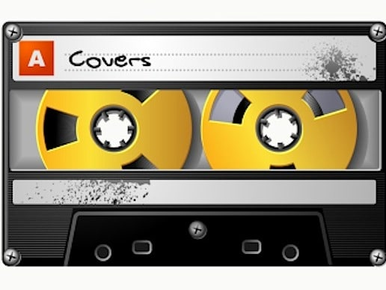
Good luck and enjoy!
Task 1: ‘Jump’ by Van Halen and a cover by Paul Anka

Resources: Version 1 https://www.youtube.com/watch?v=SwYN7mTi6HM
Version 2 https://www.youtube.com/watch?v=LYIJvBmHaQo

Your responses go in this column ☺
What are the differences between the two versions? (THINK MAD T-SHIRT)
What are the similarities between the two versions? (THINK MAD T-SHIRT)
Which version do you prefer? Give 3 musical reasons to support your preference.

Task 2: ‘Everybody Hurts’ by REM and a cover by G4

Resources: Version 1 https://www.youtube.com/watch?v=5rOiW_xY-kc
Version 2 https://www.youtube.com/watch?v=urAFi3Pu1eg

Your responses go in this column ☺
What are the differences between the two versions? (THINK MAD T-SHIRT)
What are the similarities between the two versions? (THINK MAD T-SHIRT)
Which version do you prefer? Give 3 musical reasons to support your preference.

Task 3: ‘Songbird’ by Fleetwood Mac and a cover by Eva Cassidy

Resources: Version 1 https://www.youtube.com/watch?v=wTi19MPOvDw
Version 2 https://www.youtube.com/watch?v=bTNLYeaL7No

Your responses go in this column ☺
What are the differences between the two versions? (THINK MAD T-SHIRT)
What are the similarities between the two versions? (THINK MAD T-SHIRT)
Which version do you prefer? Give 3 musical reasons to support your preference.

Task 4: ‘Make you feel my love’ by Bob Dylan and a cover by Adele

Resources: Version 1 https://www.youtube.com/watch?v=9ItmlGRB718
Version 2 https://www.youtube.com/watch?v=0put0_a--Ng

Your responses go in this column ☺
What are the differences between the two versions? (THINK MAD T-SHIRT)
What are the similarities between the two versions? (THINK MAD T-SHIRT)
Which version do you prefer? Give 3 musical reasons to support your preference.

