Y12 Media Studies Transition Tasks – Due September 2020

You are going to create a portfolio of work which will underpin your studies over the next two years. We would like you to bring this portfolio with you in September.
The following tasks from the pack must be completed:
TASK 1 – This is an article from Empire magazine and it has clips of the top 30 camera shots that you should know. As well as reading the article there are clips to demonstrate each shot. If you can, watch them and take some notes on each one.
https://www.empireonline.com/movies/features/film-studies-101-camera-shots-styles/
Choose 3 of your favourite shot types and recreate them using your phone/tablet/camera. They can be still shots or moving if you are feeling creative!
Task 2-There are two main ways of putting a sequence together. The first is called continuity editing and it is basically putting the shots together in chronological order so that time and space moves forward at the correct time. The other is referred to as non-continuity editing or montage.
Early cinema just used sequencing. The first ever movie made was called Voyage dans la Lune. Have a look at it and see how it is in a chronological sequence. WATCH - https://www.youtube.com/watch?v=BNLZntSdyKE
One of the most famous films of all time is called Citizen Kane. It starts of with someone called Charles Kane dying and then it after about 5 minutes it moves back in time to when he was a little boy playing with a sledge. This is a non-chronological sequence called a flashback which at the time was groundbreaking. It also used other flashbacks throughout the movie as in this scene WATCH - https://www.youtube.com/watch?v=sTliqWSqj2o

Think of three films/TV shows that you have watched that use flashbacks and explain in a paragraph how effective each flashback is at –
- Telling the story
- Developing the characters
- Setting the scene

Task 3
Watch at least one age appropriate film from the list of Directors listed below:
Write a 300-word film review:

Andrea Arnold
Lynne Ramsay
Spike Lee
Quentin Tarantino
Martin Scorsese
Francis Ford Coppola
Christopher Nolan
Wes Anderson
Taika Waititi

Task 4
Transition Work Newspapers Research
The Sun newspaper and find out the answers to the following questions:
- Who owns The Sun newspaper?
- Who are their primary and secondary target audiences? How do you know?
- What kind of stories do they cover?
- Is The Sun politically biased? If so, what are their main ideas and philosophies?
- Look at the front page of The Sun from Thursday 30th April 2020. Label it with the common conventions found in newspaper front covers. Use the correct terminology. Analyse the way they are targeting their specific audience. Think about the use of language, images, colour, stories covered etc.
- Terminology list— http://image.guardian.co.uk/sys-files/Guardian/ documents/2011/08/26/EducCentNewsterminology.pdf
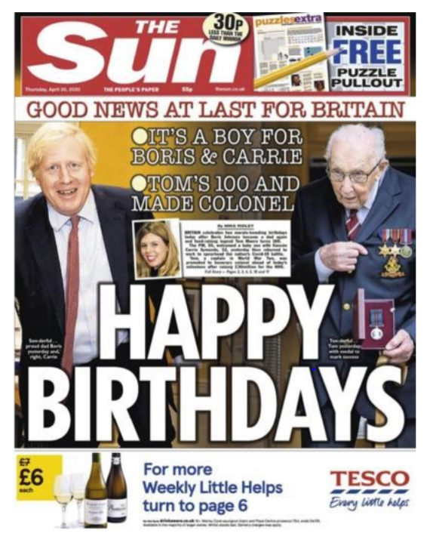

Task 5 - What is your Media Identity?
Task asks you to create a document detailing the way that media has influenced your identity.
This can be presented in any way you wish – you will be using it when we start in September, so be sure to complete this task!
- A PowerPoint
- An essay
- A vlog or podcast
- A magazine front cover
- A trailer
- A music video
- A chat show
- Or any other media form you would like to mimic

What you need to include:
- Include references to the key media products you consume and how they have shaped you
- for example – are there any TV shows, games, magazines or music that you regularly return to, talk to people about, buy merchandise for, quote from, characters that you aspire to be like? Are there social media sites you regularly visit? How has that affected what you say and how you communicate with others? Are there any influencers that you regularly tune into? Do you make your own playlists on Spotify? Any media product you use says something about who you are and that is what we want to find out about.
- Evidence of research from theories on the specification
  - David Gauntlett – Media, Gender and Identity
- http://davidgauntlett.com/making-media-studies/theories-of-identity-new-media-studies-a-as-level/
- https://pdfs.semanticscholar.org/1fbe/dda1bfb55e1ee7c880d8cbddd588b02f712d.pdf
  - Uses and Gratifications Theory
- https://revisionworld.com/a2-level-level-revision/media-studies-level-revision/uses-and-gratifications-theory
  - Clay Shirky – End of Audience Theory
- https://www.youtube.com/watch?v=xP1F0opghMY
- https://www.bfi.org.uk/sites/bfi.org.uk/files/downloads/bfi-teaching-clay-shirky-technology-changing-audiences-christine-bell.pdf
- If you choose to mimic a particular media form – you need to include expected elements and features for that (e.g. a magazine – a mast head, a main image and cover lines)

