A Level History Project

Conduct a research and answer the following question: How justified was the bombing of Germany?

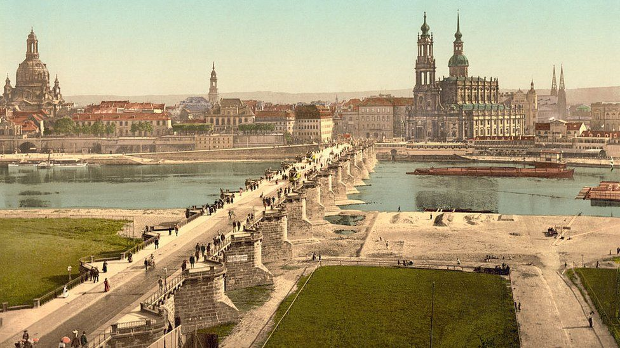
A colour image of Dresden from 1900, showing a number of monuments which were later heavily damaged in the bombing

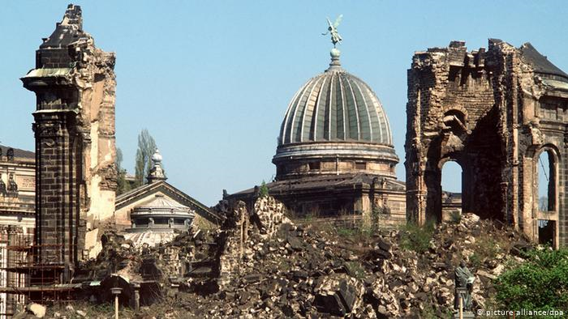Ruins of a church in Dresden after Allied bombing, 1945.

"The firestorm is incredible... Insane fear grips me and from then on I repeat one simple sentence to myself continuously: 'I don't want to burn to death'. I do not know how many people I fell over. I know only one thing: that I must not burn."

On 13 February 1945, British aircraft launched an attack on the eastern German city of Dresden. In the days that followed, they and their US allies would drop nearly 4,000 tons of bombs in the assault.

The ensuing firestorm killed 25,000 people, ravaging the city centre, sucking the oxygen from the air and suffocating people trying to escape the flames.

Dresden was not unique. Allied bombers killed tens of thousands and destroyed large areas with attacks on Cologne, Hamburg and Berlin, and the Japanese cities of Tokyo, Hiroshima and Nagasaki.

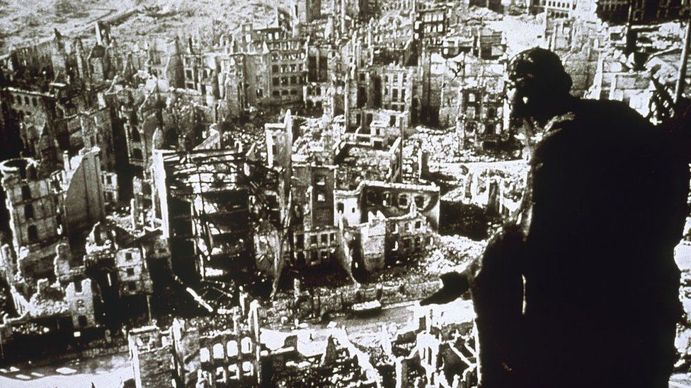

However, the bombing has become one of the most controversial Allied acts of World War Two. Some have questioned the military value of Dresden. Even British Prime Minister Winston Churchill expressed doubts immediately after the attack.

"It seems to me that the moment has come when the question of bombing of German cities simply for the sake of increasing the terror, though under other pretexts, should be reviewed," he wrote in a memo.

"The destruction of Dresden remains a serious query against the conduct of Allied bombing."

Before you start answering the top question, you would have to conduct a research for the following:
- The destruction of Spanish city of Guernica, 26 April 1937.
- Bombing of Poland in 1939, the destruction of Warsaw.
- The Blitz, bombing of London.
- The destruction of Dresden.

What happened, who was responsible, why did it happen, the extent of destruction, when did it happen, what were the consequences, what sources say about these events, compare casualties and destruction of significant historical buildings, who supported-who was against the bombings?
Once you have enough evidence, answers, pictures, videos, interviews, eyewitnesses’ testimonies, you can answer the top question: How justified was the bombing of Germany?

YOUR work can be presented on a booklet, PowerPoint presentation or posters.

Thank you,
Mr Hryniewicz.

