Christina Rossetti

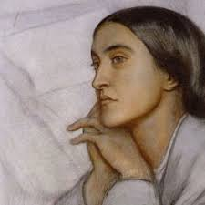

What was the ‘Pre-Raphaelite’ brotherhood and why did the familial involvement influence her poetry?
What was her reading ‘diet’ and how did this mirror the way she conducted her life?
Referred to herself as the ‘bride of Christ’ yet much repressed sexual imagery in her poetry- research the paternal breakdown and how this may have affected the fifteen year old Christina on a number of levels.
What was the Mary Magdalene Penitentiary? Why do you think Rossetti crafted these links?
Was Rossetti a feminist? Reasons for yes and reasons for no…
