Drama Unit 1: Tennessee Williams’ A Streetcar Named Desire and Shakespeare’s Othello

On Microsoft Stream (SharePoint) please watch the performance of A Streetcar Named Desire and please purchase the above version.
On Thursday 21st May at 7.00 p.m. on YouTube Channel the National Theatre are streaming a performance of A Streetcar Named Desire. Please watch.

At this point it would be useful for you to consider how you respond to each character as
presented. If we use the terms from classical tragedy, how do you respond to the
protagonist, Blanche, and the antagonist, Stanley?

Please purchase a copy of Tennessee Williams’ biography, Memoirs, and read it. It is a primary source of information for events that happen in the text.
Research and keep detailed notes of how ‘Kitchen-sink drama’ evolved in Britain. A Streetcar Named Desire is termed a domestic drama, which was also a cultural shift – like ‘kitchen-sink’ – so a comparison/links to, are very useful.

Context: You will glean all you need biographically from reading Williams’ Memoirs. Additionally, research and notate copiously:
The American Civil War and how the Old South emerged into a New South
The ‘immigrant belt’ of 1940s (represented by the L&N tracks in the text)
New Orleans in the 1940s:
- Racial mores
- Sexual mores
- Immigration
- Emergence of the new urban proletariat (Marxism)
- Women and their societal role
- Districts (the Quarter and the Garden District are mentioned in the text’s exposition)
- Cultural mores and the role of music – ‘The Blue Piano’

For Othello, 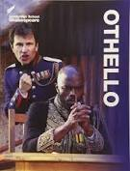, purchase this version please and read it. As with A Streetcar Named Desire watch a performance of it, 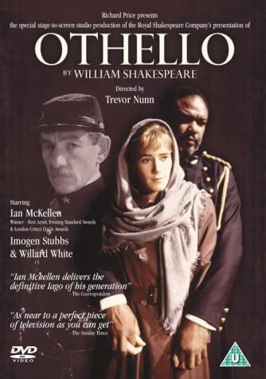. This version should be on Microsoft Stream (SharePoint) very shortly.
To help you with understanding of the first reading of the text, use a modern version alongside of it (No Fear Shakespeare is one). Additionally, take copious notes as follows:
England in 1603 and its mores (views/conventions) on:
- Race. This is the first Shakespeare text to have a protagonist that is non-white in racial terms. Why is Shakespeare’s protagonist a Moor? Queen Elizabeth – in 1596 – opined about Moors (Muslim people of NW African descent) ‘there are of late divers blackmoores brought into this realme, of which kinde of people there are allready here too manie’. What societal views, expounded by Elizabeth 1st here, were there on miscegenation and how xenophobic was Elizabethan/Jacobean England?
- Why did Shakespeare write a domestic tragedy about jealousy, and then make the husband a Moor? What is the text’s dramatic premise/s?
- The Jacobeans and the role of women? How were they viewed? Focus your response on your initial views on Desdemona, Emilia and Bianca in the text.
- King James 1st (came to the throne in 1603) and the supernatural – his views?
- Why does the text open in Venice? What was this city synonymous with?
- How is Iago’s status as the text’s antagonist presented and what ideas are being explored by Shakespeare here? He soliloquises first and the most, why as the text’s antagonist and not Othello, as its protagonist.

