A LEVEL DRAMA & THEATRE
2020 -2022

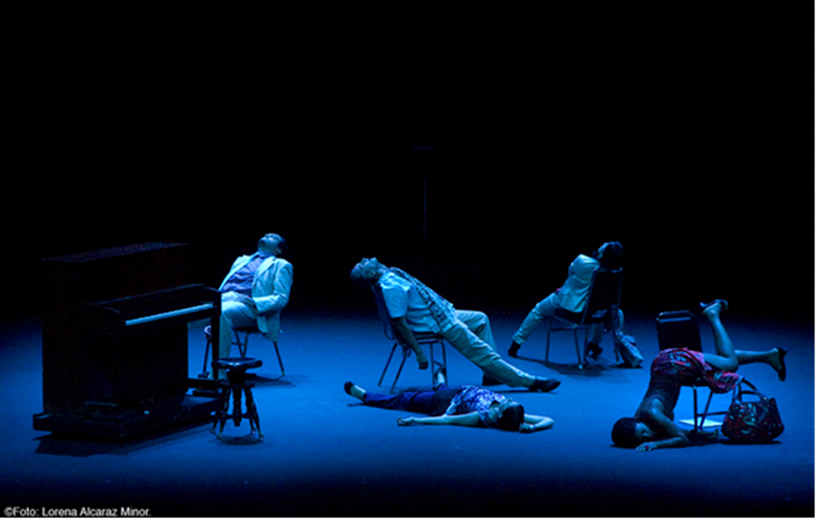

Blessed Hugh Faringdon Catholic School

WELCOME to the A LEVEL DRAMA & THEATRE course and congratulations on your GCSE results. I take it as a compliment that, as option subjects you have chosen Drama and I look forward to taking you through the next 2 years.

You are about to embark on a journey of exploration. An exploration of how drama and theatre is made and presented to an audience. This journey will start with an induction project where you will develop the skills and acquire the tools needed to be a successful Drama & Theatre student at ‘A’ Level.

Over the two years, you will study various plays and theatre styles from Classic to Contemporary playwrights and companies such as Stanislavski, Frantic Assembly, Shakespeare or Dario Fo. You will be asked to consider how you might direct, perform and design for productions, and you will also develop your evaluative and analytical skills in order to review live theatre effectively. To support this work you will also go on theatre trips and take part in drama workshops. Your explorations into all these areas of Drama & Theatre will end in a written exam during the summer term on:
- two complete performance texts from different historical periods
- one extract from a third contrasting text.

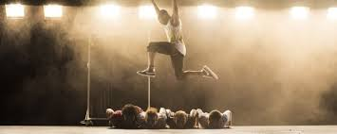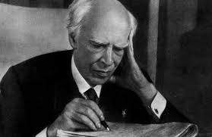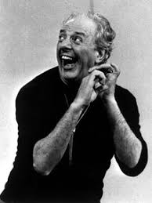
Frantic Assembly Stanislavski Dario Fo

During the two years we will also introduce you to a range of theatre practitioners, showing you how their ideas on theatre can influence and shape the production process from page to stage. As your journey continues you will then be asked to choose two practitioners to research in greater depth and detail. The ideas and work of your chosen practitioners will influence and shape the work you create for your practical and written exams.

J. Gudiño
Head of Drama

You are part of our Drama Family, in our family we have expectations…

- Believe in each other
- Support each other
- We are a team in drama ‘all of us’
- Contribute your ideas and opinions
- Listen and value other people’s views
- Understand that you may have differing opinions but that is you’re right, however
- Always be mindful of other people’s feelings.
- Be brave there is no wrong answer when it comes to creating, collaborate and be adventurous and innovative.
- Do not put a ceiling on the possibilities challenge yourself, be as creative as you can
- Be independent, yet collaborative, use divergent thinking, make sure you use a growth mindset and most of all
- Attend all lessons
- Attend all theatre shows
- Working together as a group is key, but this must mean that there is no ridicule
- You will all have strengths and weaknesses; you need to therefore support each other
- You will need to read in front of each other, again support is crucial
- Complete all homework for the deadline
- Turn up to rehearsals after school and during lunch breaks
- When I or your peers are talking, you are not, when you are talking I’m not and noryou’re your peers, key to working well together and getting a good grade is mutual respect
- Everyone is entitled to their opinion; you listen and then you can give your own

COMPONENTS
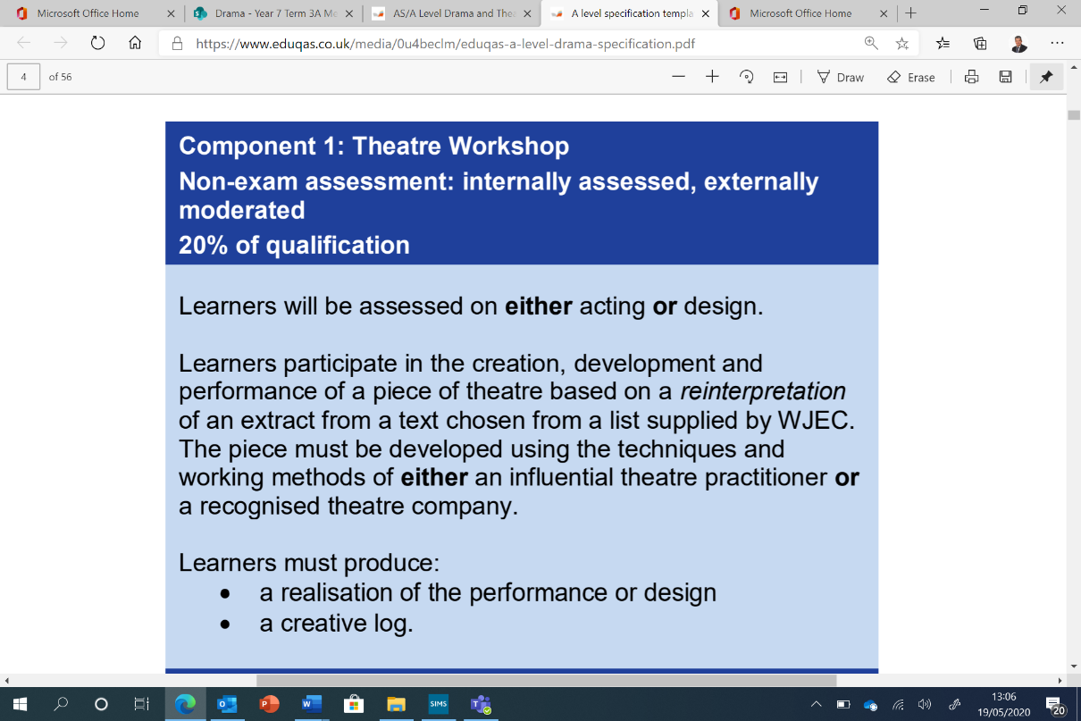

In a nutshell:
One adapted performance from an existing play
under the influence of a practitioner
- The creative logo should be between 1200-1500 words and must include knowledge and influence of your practitioner
These will be assessed by me and moderated by Eduqas

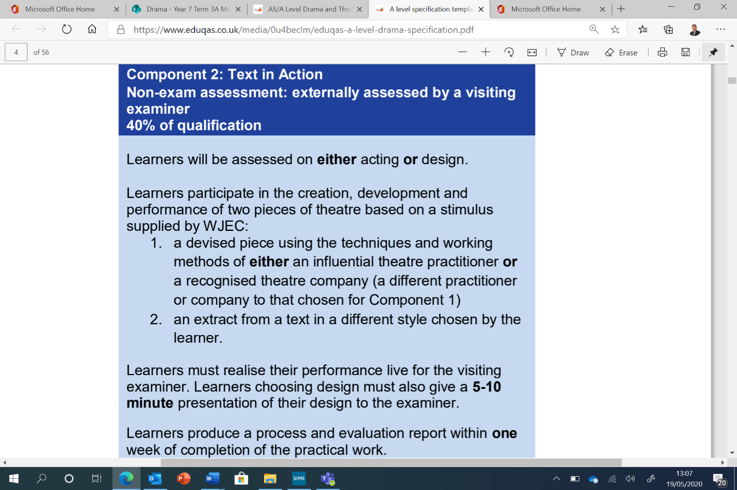
In a nutshell:
- A devised piece from a stimulus provided by EDUQAS
under the influence of a different practitioner
- An extract from the chosen play in component 1 but, performed in a different style.
- A process evaluation report on both pieces performed (this work must be handed in one week after the performances and should not be more than 3000 words.
- Assessed by an external EDUQAS examiner

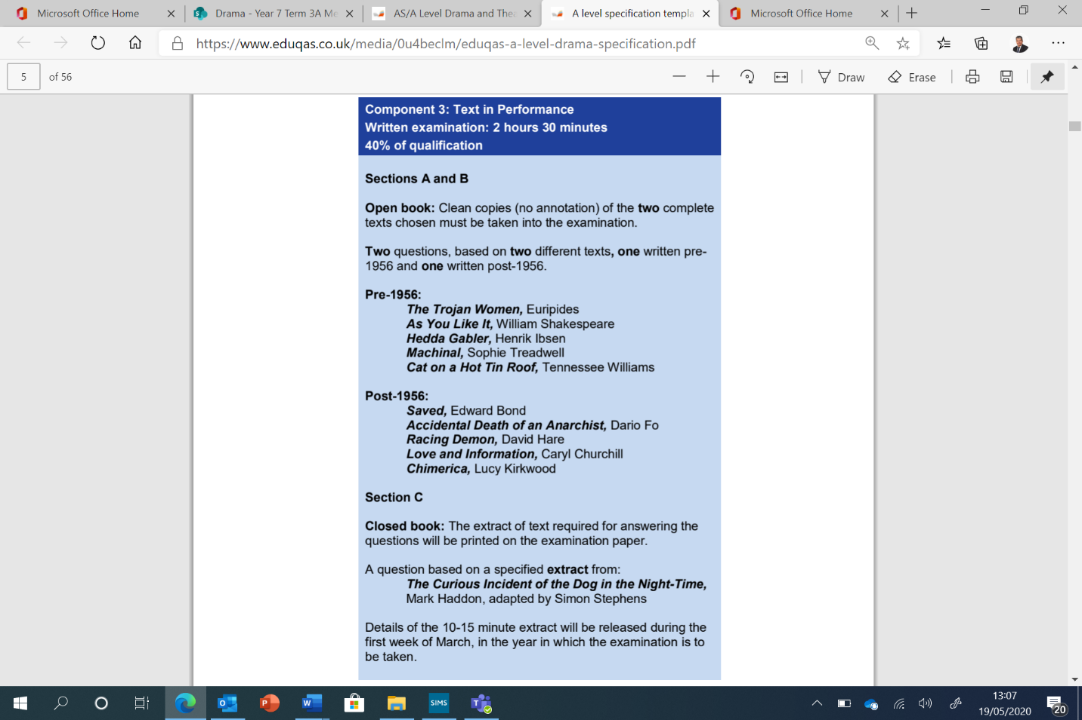

In a nutshell:
- SECTION A – A series of questions on a specified extract from the chosen text post-1956 (interpreting a character)
- SECTION B – An essay question on the chosen text pre-1956 (from the perspective of either actor, designer or director)
- SECTION C– A question on the specified extract from ‘The Curious Incident of the Dog in the Night-Time’ (from the perspective of either actor, designer or director)

How to Survive Drama A – Level

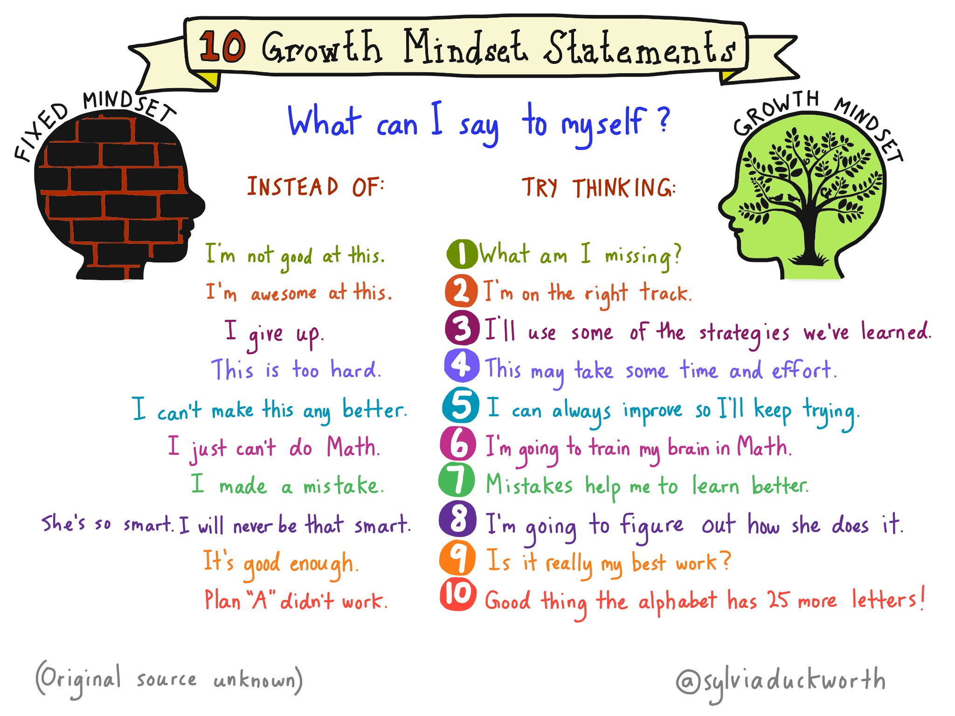

Advice from previous students:
“Be confident and ready to try new things, make sure you throw yourself into everything asked of you, even if it’s out of your comfort zone”

"Never give up. Drama is a very hard subject, but I've learned that being determined is the best way forward. Work with each other. Do not be afraid of teamwork because you'll need to embrace it fully and it can be so rewarding"

“Make sure that everything is organized into different sections of your folder. Keep EVERY exam you do because it will help towards your progress… HAVE FUN!”

Now, your first assignment!
Below is a list of Practitioners, you will need to know who these people/companies are and how they influence your work. E.g. Brecht likes to use Placards in his work so you might use them as well

Peter Brook | Constantin Stanislvaski | Punchdrunk | Antoine Artaud | Complicite | DV8
Bertolt Brecht | Steven Berkoff | Katie Mitchell | Frantic Assembly | Rupert Goold | Augusto Boal

Pick two from the table above and you must complete the following questions and activities:

- What is a practitioner?
- What is the difference between style/genre?
- What style does this practitioner use?
- Create a presentation on this Practitioner
- Create a workshop of 10 minutes which you will lead, to explore how this practitioner works
This is due the FIRST LESSON BACK in September 2020. Any questions please do not hesitate to contact me J.Gudino@hughfaringdon.org

